**Introduction**

I am assigned with the task to develop a website to book a photographer online. I decide to develop this application using PHP. I first started with requirement analysis by studying various requirements of people to get a perfect knowledge about the portal.

Then I started preparing a list of photography categories according to the requirement analysis. After finalizing the initial list, I started the design of the website which was followed with implementation of the functionalities.

I have followed the iterative waterfall model for development of the website. Then I have tested the website under various environmental conditions.

Existing system:-

“The way in which work is currently performed is called as companies existing system”

Currently to book a photographer the a person has to visit different photo studios which is a very time and effort consuming job, the persons struggles to get a perfect photographer according to their requirement.

After selecting the photo studio the customer has to tell the requirements regarding the photography to the photographer which again is a time consuming task.

And finally the person is able to book a photographer by paying some money in advance.

So, the existing system is a very time and effort consuming system, It leads to the wastage of time and man power.

**Scope of Work**

Online Photographer booking system gives following scopes:-

* The problem of going to places and searching for a good photographer is solved which saves time and effort.
* Now anybody can book a photographer from anywhere.
* The negotiation issues would also be solved.
* Every type of photography will be available on one platform.
* The convenience of people would increase.

**Feasibility Study**

Feasibility study is carried out whenever there is a complex problem or an opportunity. It is in fact a preliminary investigation, which emphasizes the look before you leap approach to any important project.

A feasibility study is undertaken to determine that whether your system is running smoothly through proper channel without any obstacles or interpretation.

It provides an overview of the existing problem and helps us to detect whether a feasible solution existing for the problem. This is essential to avoid spending large resources on a project and then repeat it on later.

So now it's time to analyze whether the developed project “ONLINE PHOTOGRAPHER BOOKING PORTAL” is operationally' technically and economically feasible or not.

Operational Feasibility:-

Basic information needs to be entered only once.

Faster processing of data to give proper output.

Hence, the proposed system is operationally feasible.

Technical Feasibility:-

The minimum requirement for effective and efficient working of the Portal are as follows:.

LINUX, Ubuntu or Windows latest Operating system,

Internet Connection.

A latest Web Browser.

*“Considering today's software & hardware trends, the proposed* system is technically feasible”.

**Need for the system**

In today's world, time factor is given much priority than any other thing. Hence, use of computerization can reduce time consumption.

1. To get a photographer without going anywhere and wasting time in search of a good one.
2. We can get much photography related facilities on one platform.
3. The photographers will be available at a reasonable price so the issue of Negotiation of price will be solved.
4. The process to book a Photographer will become very easy.
5. People will get good photography experience at a very affordable price range.

Use of the Online photographer booking portal supports the concept of "effortless facility.”

Requirement Analysis:

Fact Finding Techniques:-To study any system the analyst needs to do collect facts and all relevant information. The facts when expressed in quantitative form are termed as data. The success of any project is depended upon the accuracy of available data. Accurate information can be collected with help of certain methods/ techniques. These specific methods for finding information of the system are termed as fact finding techniques. Interview, Questionnaire, Record View and Observations are the different fact finding techniques used by the analyst. The analyst may use more than one technique for investigation.   
Interview:-This method is used to collect the information from groups or individuals. Analyst selects the people who are related with the system for the interview. In this method the analyst sits face to face with the people and records their responses. The interviewer must plan in advance the type of questions he/ she is going to ask and should be ready to answer any type of question. He should also choose a suitable place and time which will be comfortable for the respondent.

Questionnaire:-It is the technique used to extract information from number of people. This method can be adopted and used only by a skillful analyst. The Questionnaire consists of series of questions framed together in logical manner. The questions are simple, clear and to the point. This method is very useful for attaining information from people who are concerned with the usage of the system and who are living in different countries. The questionnaire can be mailed or send to people by post. This is the cheapest source of fact finding.  
Observation:-  
Unlike the other fact finding techniques, in this method the analyst himself visits the organization and observes and understand the flow of documents, working of the existing system, the users of the system etc. For this method to be adopted it takes an analyst to perform this job as he knows which points should be noticed and highlighted. In analyst may observe the unwanted things as well and simply cause delay in the development of the new system.

**Operating Environment**

Hardware Requirement:-

All the physical equipments, input devices, output devices; processor of the computer is called as hardware.

The hardware requirement means the minimum hardware required to operate the system. The hardware is used in accordance with the operating system.

17" Monitor

RAM min 2GB

Hard disk 160GB

Software Requirement:-

Instruction that when execute provide desired function and performance.

Data structure and enable the program to adequately manipulate the information.

Domains that describe the operation and use of program.

Software Requirement:-

LINUX, Ubuntu or Windows latest Operating system.

**Proposed system**

Due to the Online Photographer Booking Portal will enjoy following advantages:-

* Easy Appointments.
* Prompt services.
* Easy to provide Photography related facilities.
* Reduction of human effort.
* Ultra modern technical environment.
* Help in future plans.
* Useful in development & growth.
* Increase speed of work.

In this way proposed poetal will help to book a photographer without any difficulties.

And overcome all problems occurred due to current manual system.

**Objectives**

* On the basis of this system, it should be easy to provide the facility to a person.
* Able to easily manage the contents of the system.
* Using this system, retrieval of information should get easily.
* Storing the details of customers with Photographers information which will be very convenient.
* It would be easy to choose the photographer according to requirement and price range.
* Able to get reports of all transaction and details filled in system.

**Data Dictionary**

Registered Table:

|  |  |  |  |
| --- | --- | --- | --- |
| **Field Name** | **Description** | **Data Type** | **Constraint** |
| Id | Customer Id | Integer(11) | Primary key |
| firstname | Customer Firstname | Varchar(25) | Not Null |
| lastname | Customer Lastname | Varchar(25) | Not Null |
| username | Customer Username | Varchar(32) | Not Null |
| password | Customer Password | Varchar(300) | Not Null |
| email | Customer Email | Varchar(32) | Not Null |
| mobile | Customer Mobile no. | Varchar(12) | Not Null |
| address | Customer Address | Varchar(50) | Not Null |
| gender | Customer Gender | Varchar(15) | Not Null |
| city | Customer City | Varchar(15) | Not Null |
| zip | Customer Zip code | Integer(8) | Not Null |

Photographers Table:

|  |  |  |  |
| --- | --- | --- | --- |
| **Field Name** | **Description** | **Data Type** | **Constraint** |
| p_Id | Photographer Id | Integer(10) | Primary key |
| p_Name | Photographer Name | Varchar(30) | Not Null |
| p_number | Photographer Mobile no. | Varchar(12) | Not Null |
| p_email | Photographer Email | Varchar(50) | Not Null |
| p_price | Photographer Charge | Varchar(10) | Not Null |

User_photo Table:

|  |  |  |  |
| --- | --- | --- | --- |
| **Field Name** | **Description** | **Data Type** | **Constraint** |
| b_Id | Booking Id | Integer(11) | Primary key |
| id | Customer id | integer(11) | Not Null |
| p_id | Photographers id | integer(11) | Not Null |
| place | Service place | Varchar(50) | Not Null |
| category | Photography category | Varchar(15) | Not Null |
| date | Booking Date | Varchar(10) | Not Null |

**Entity Relationship Diagram:-**

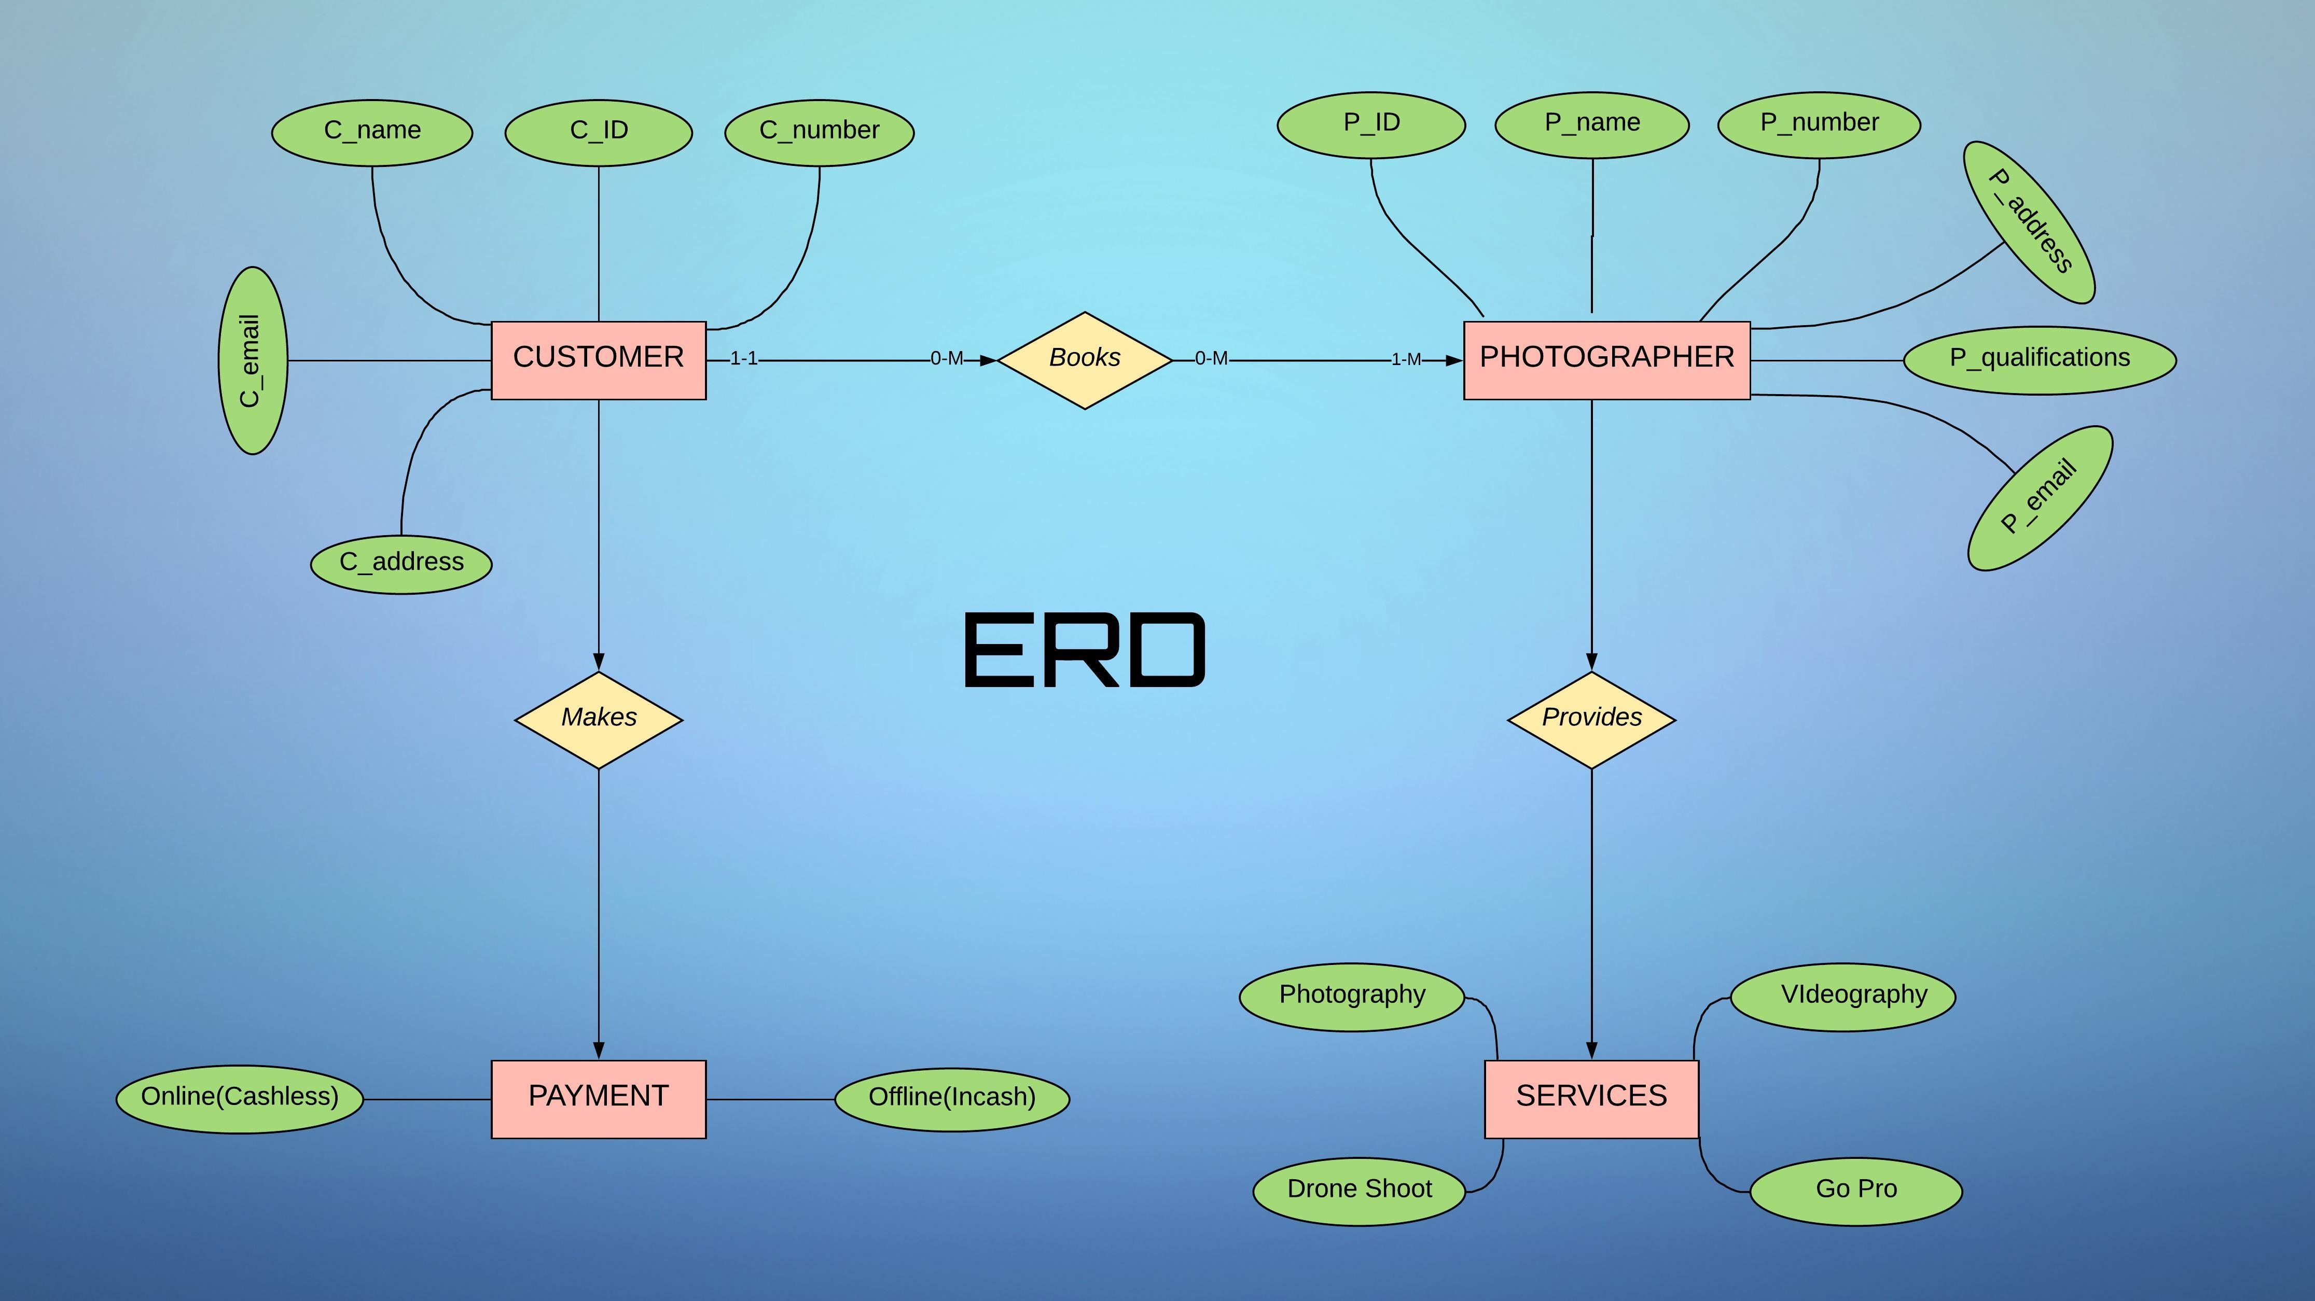

**Data flow diagram:**

Level 0:

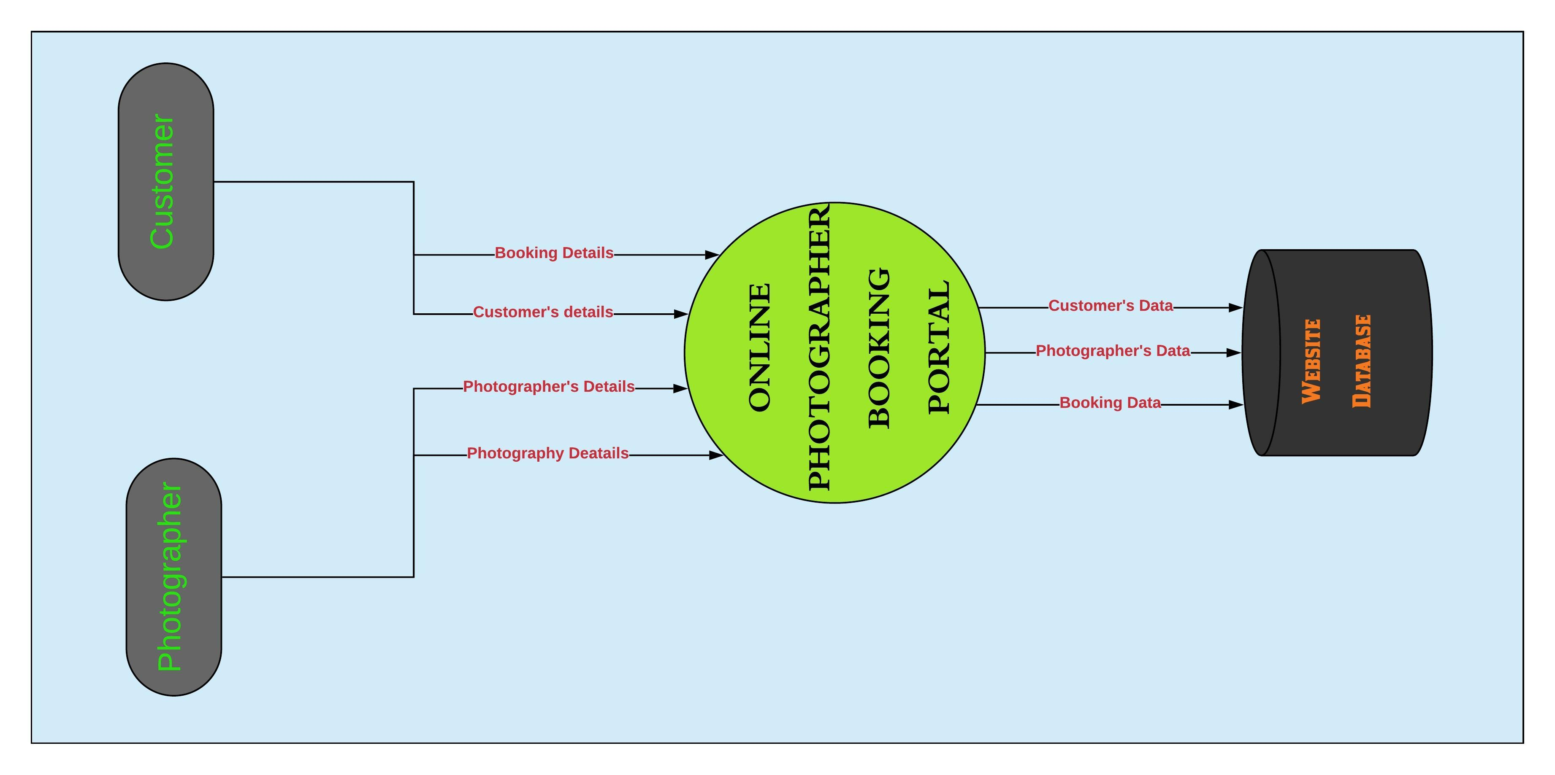

**DFD Level 1:**

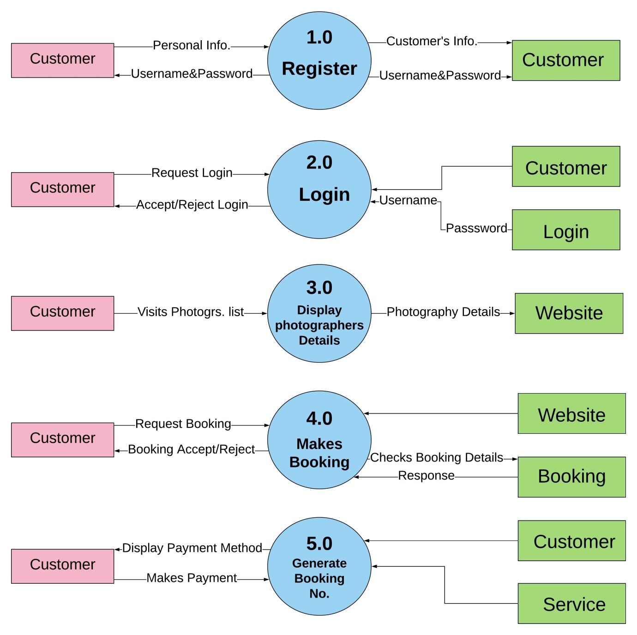

**UML Diagrams:**

Class Diagram:



Activity Diagram:





Sequence Diagram:



Use case Diagram:



**Input Output Screens**

HOME SCREEN

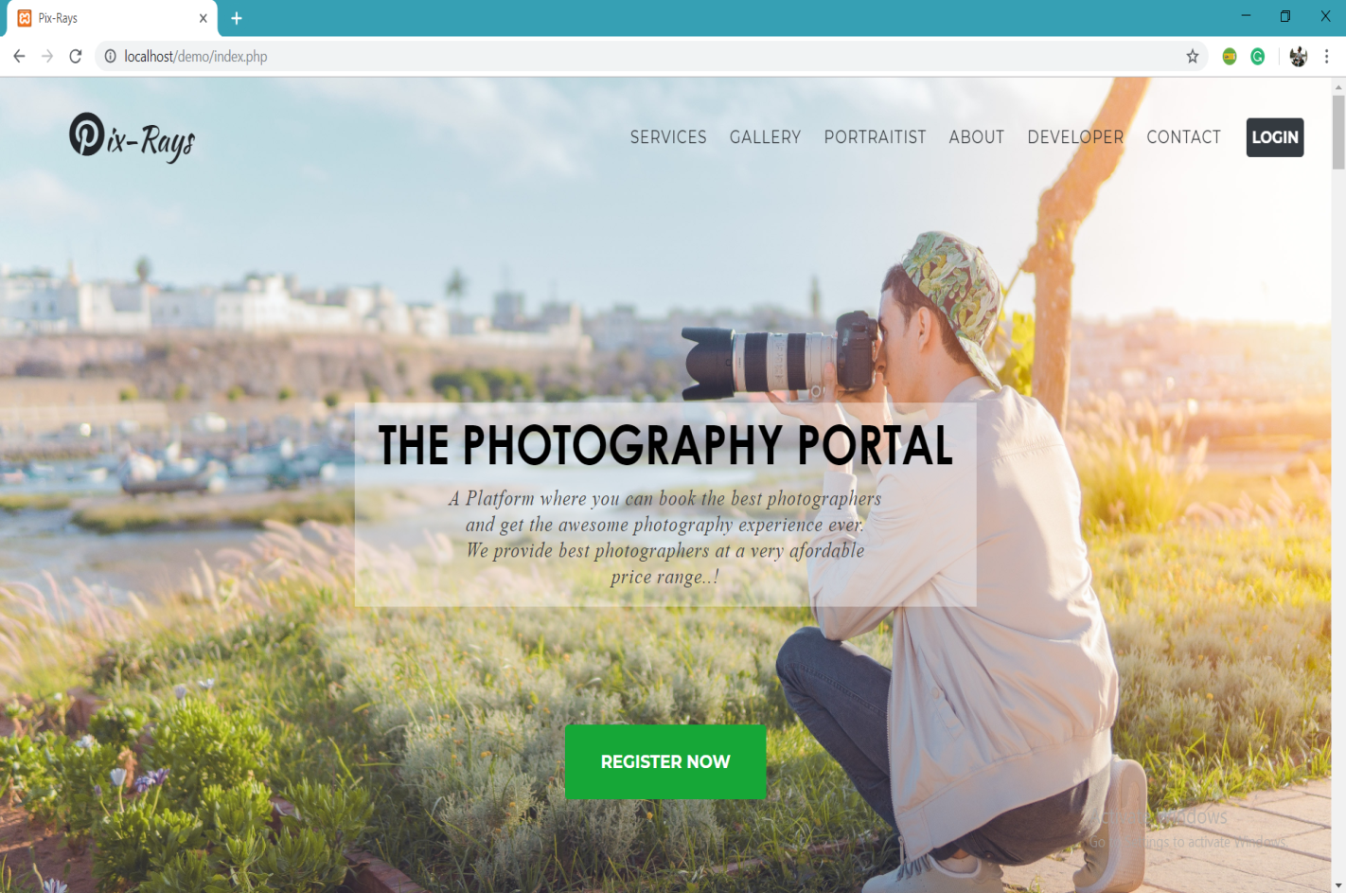

SERVICES

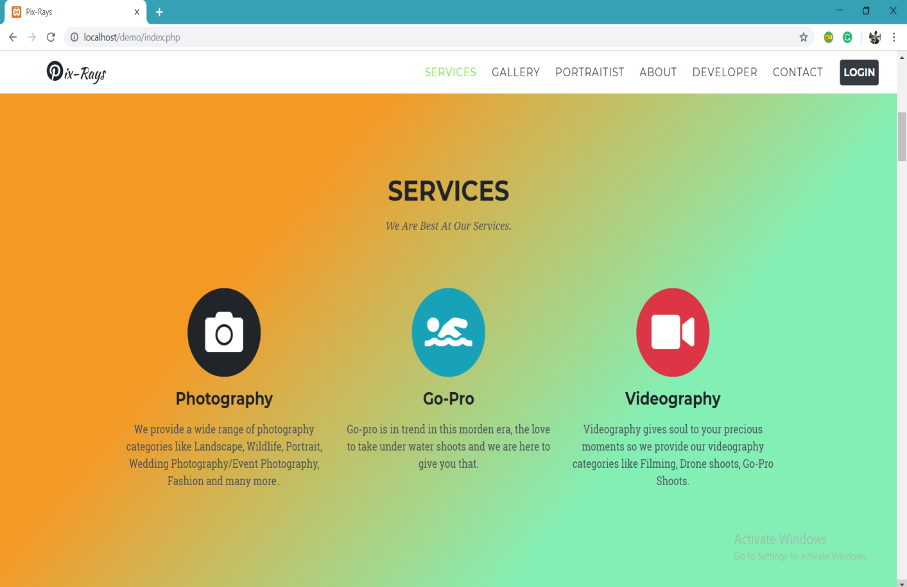

PHOTO GALLERY

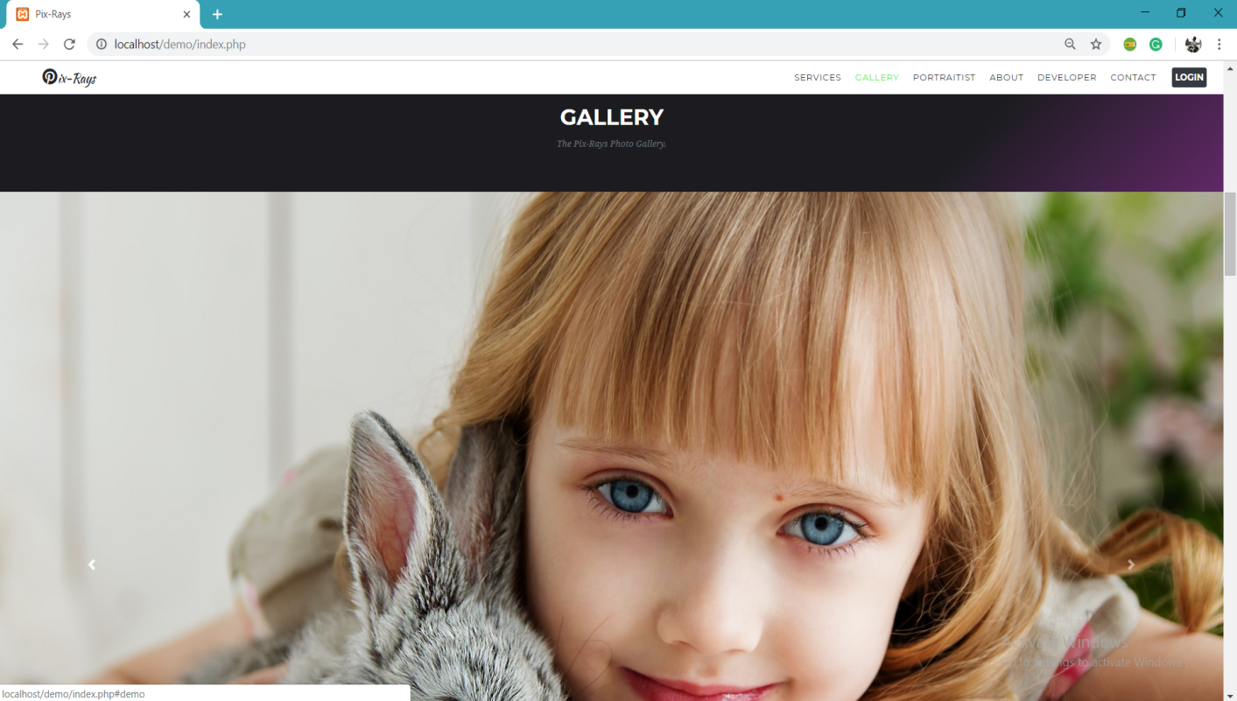



PHOTOGRAPHERS

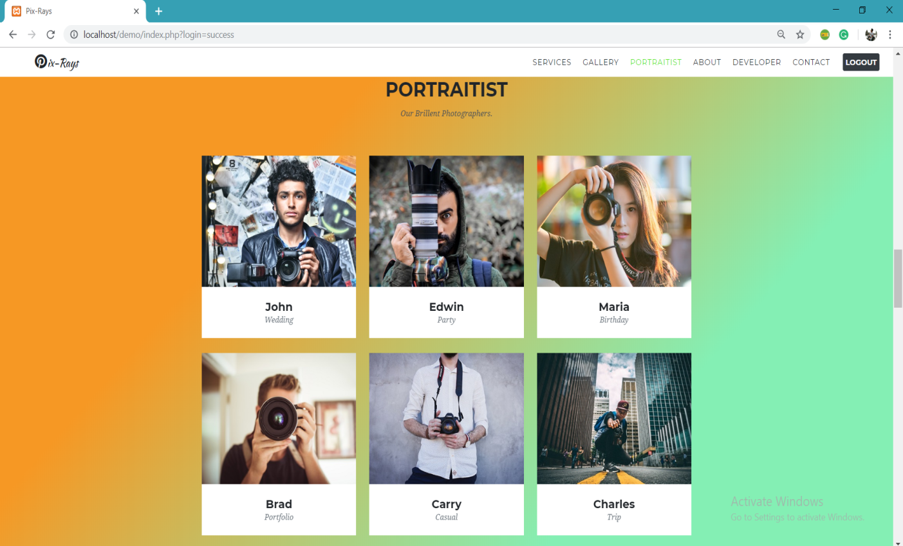

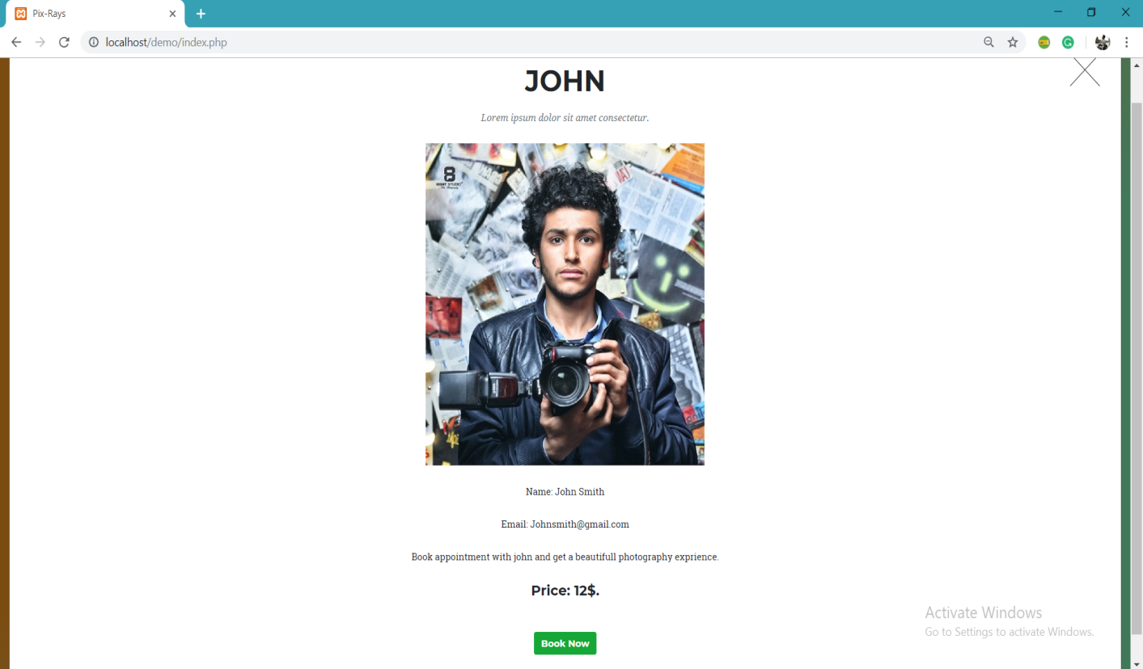

CONTACT PAGE

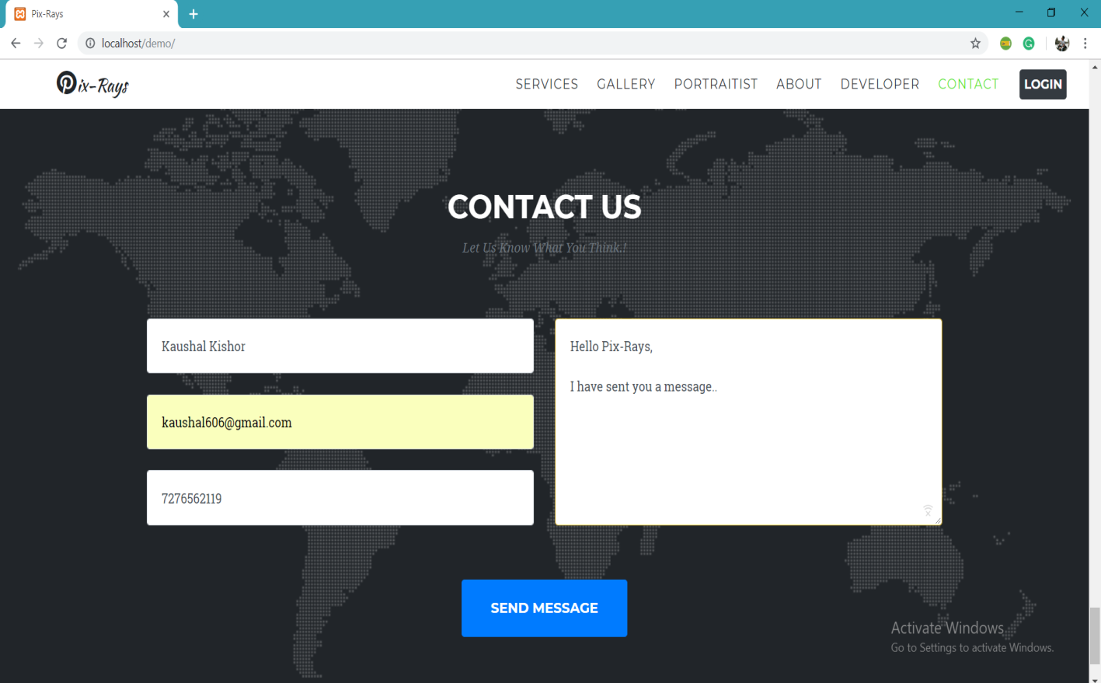

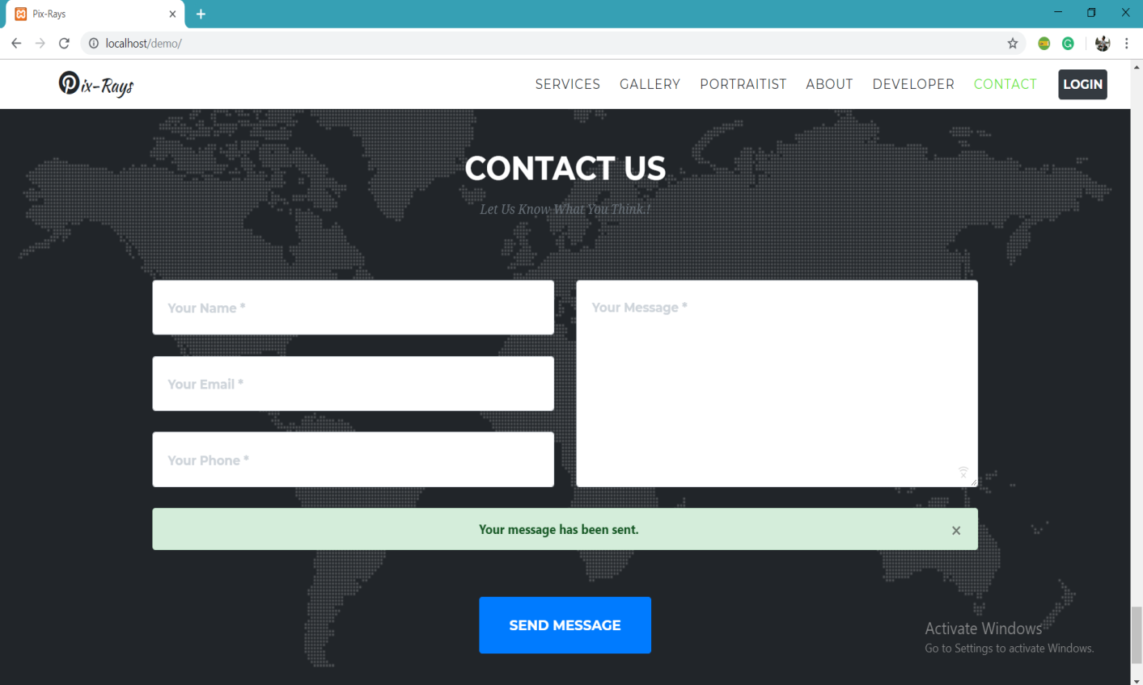

REGISTRATION PAGE & VALIDATIONS

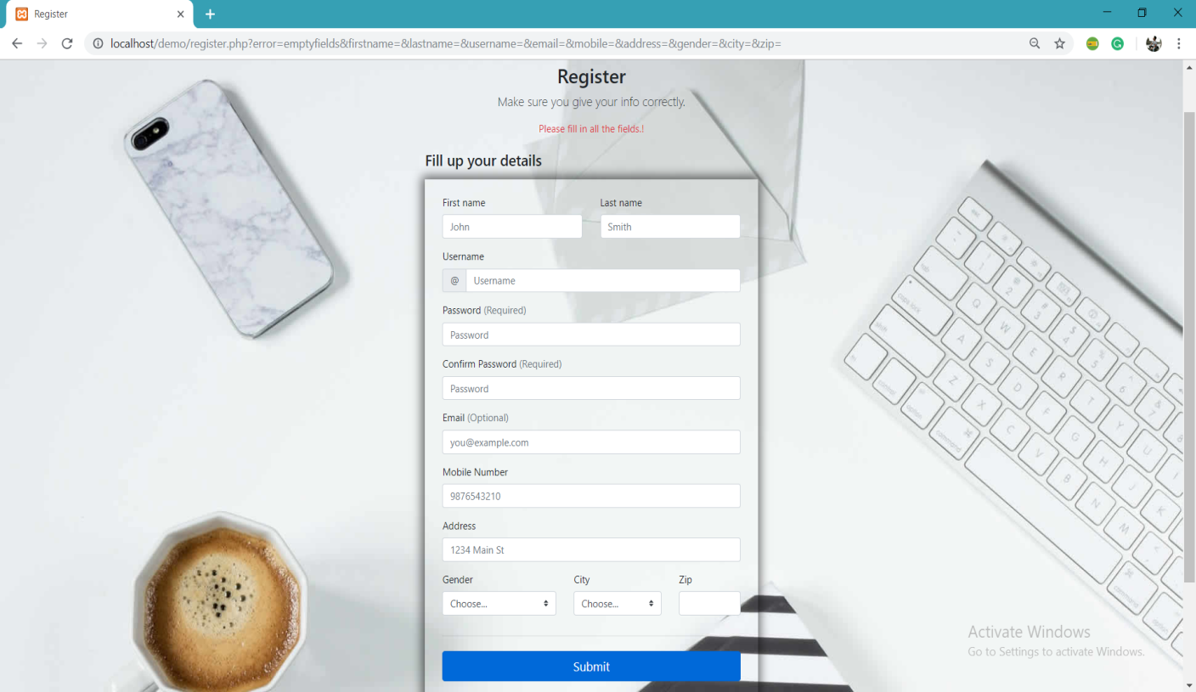

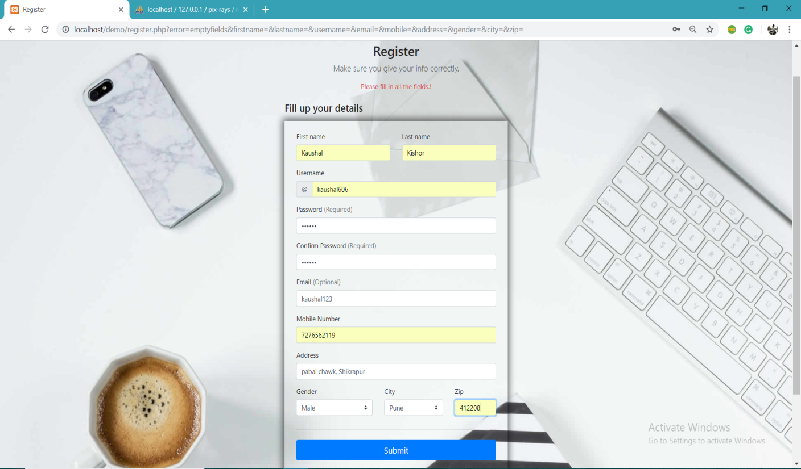



**LOGIN SYSTEM**

User Registers:-

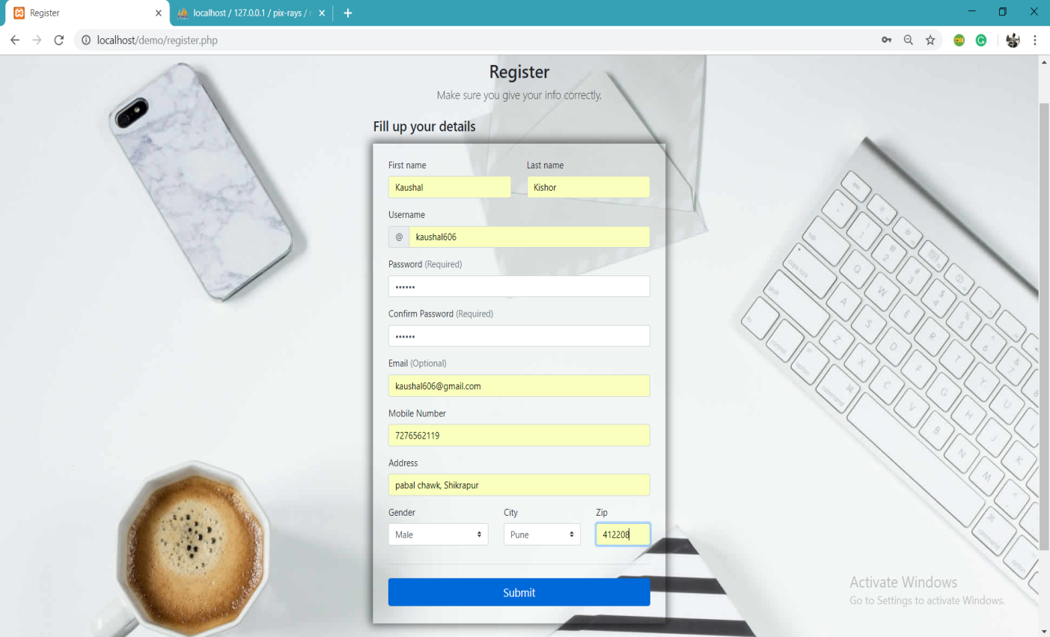

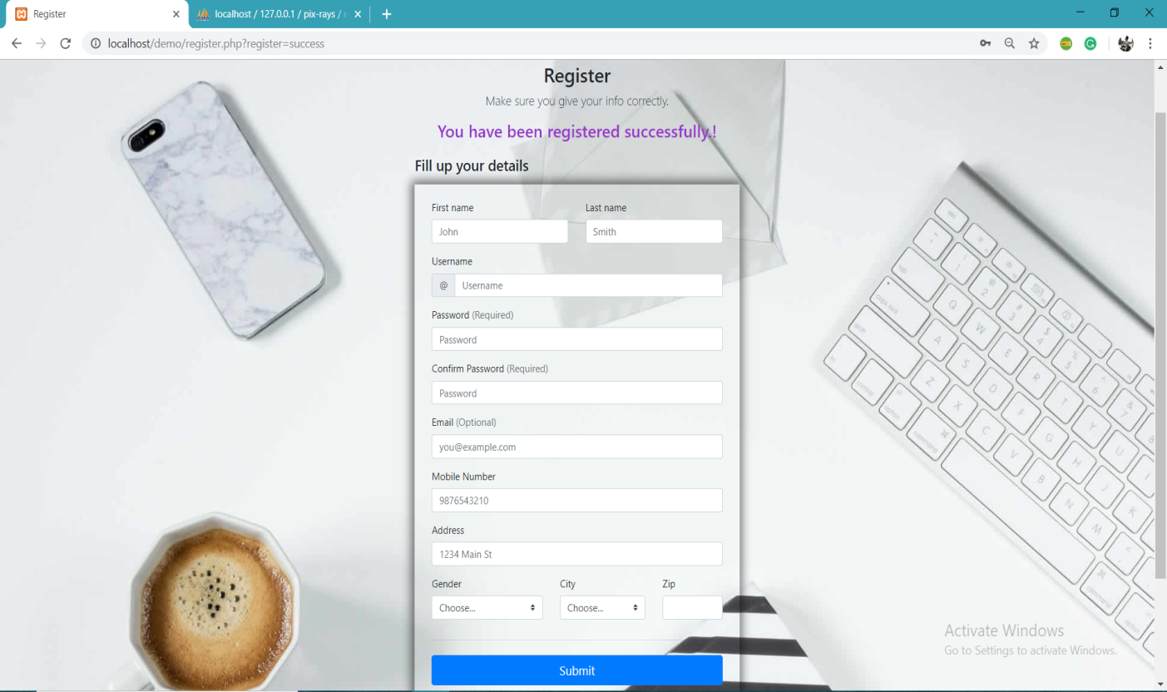

User Logins:-

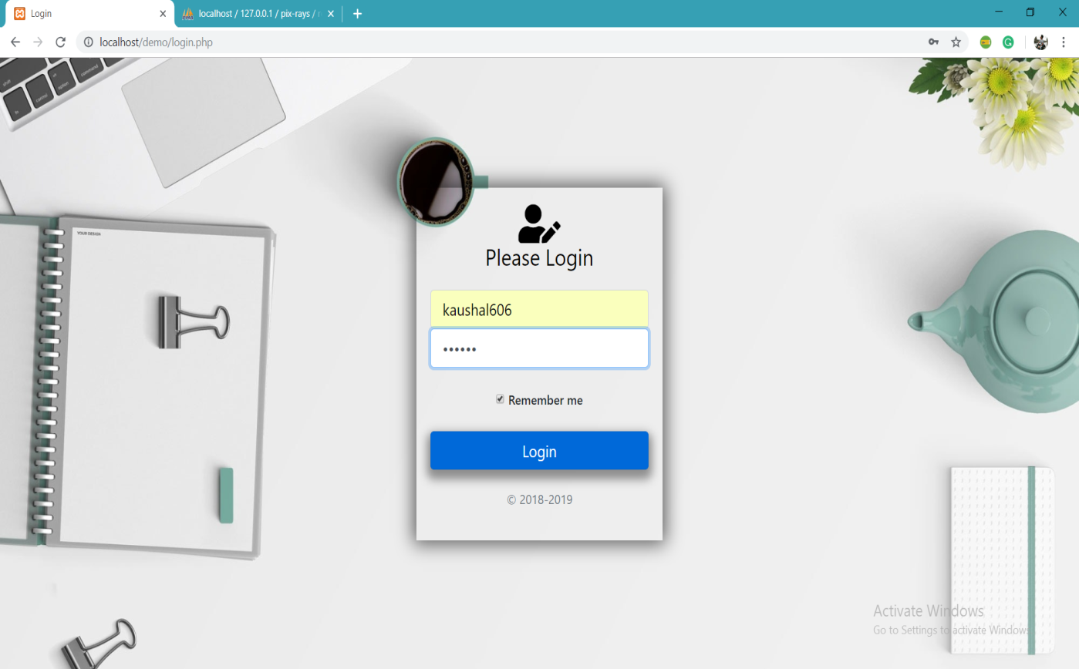

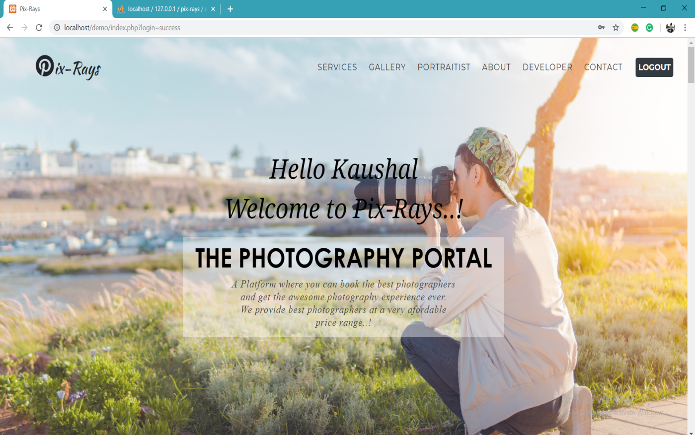

User Books Photographer:-

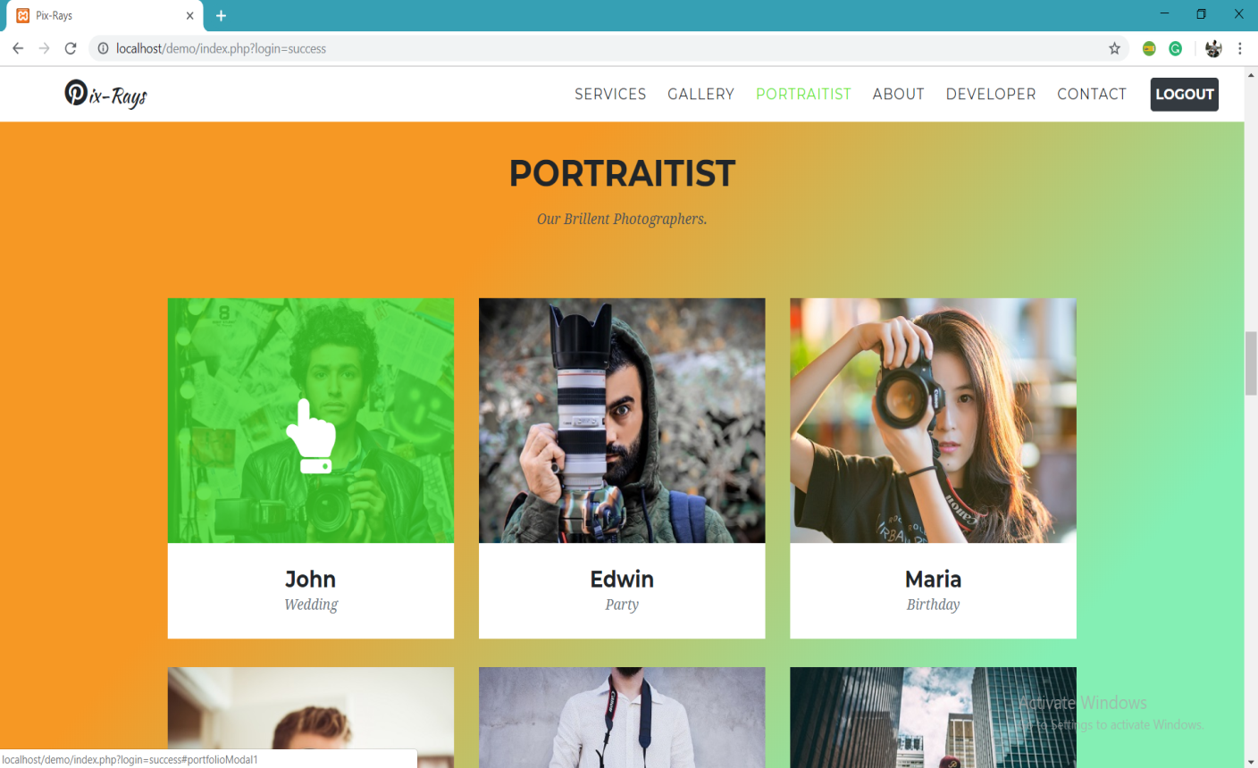

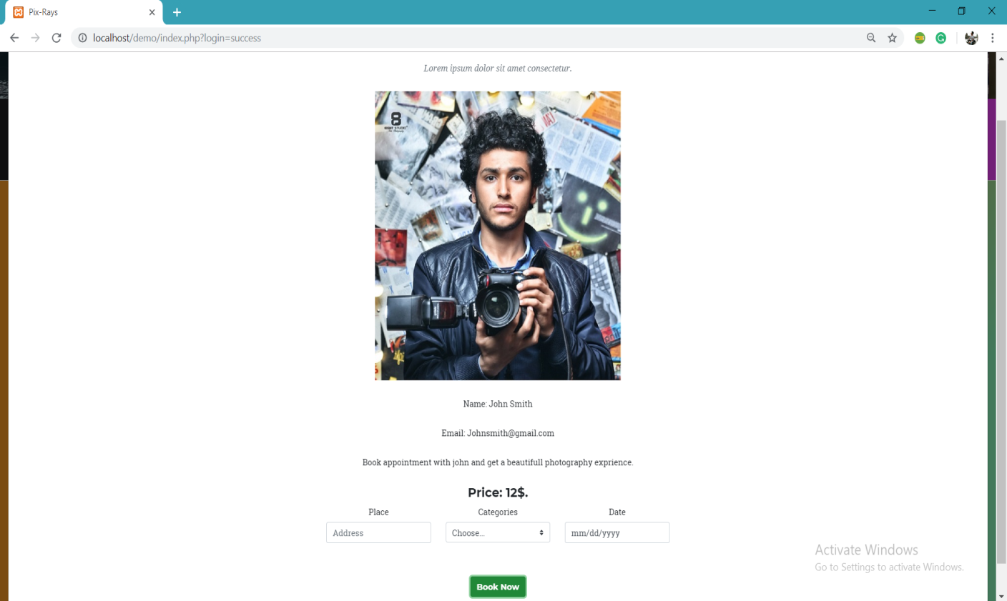

User fills details:-



Booking Accepted:-

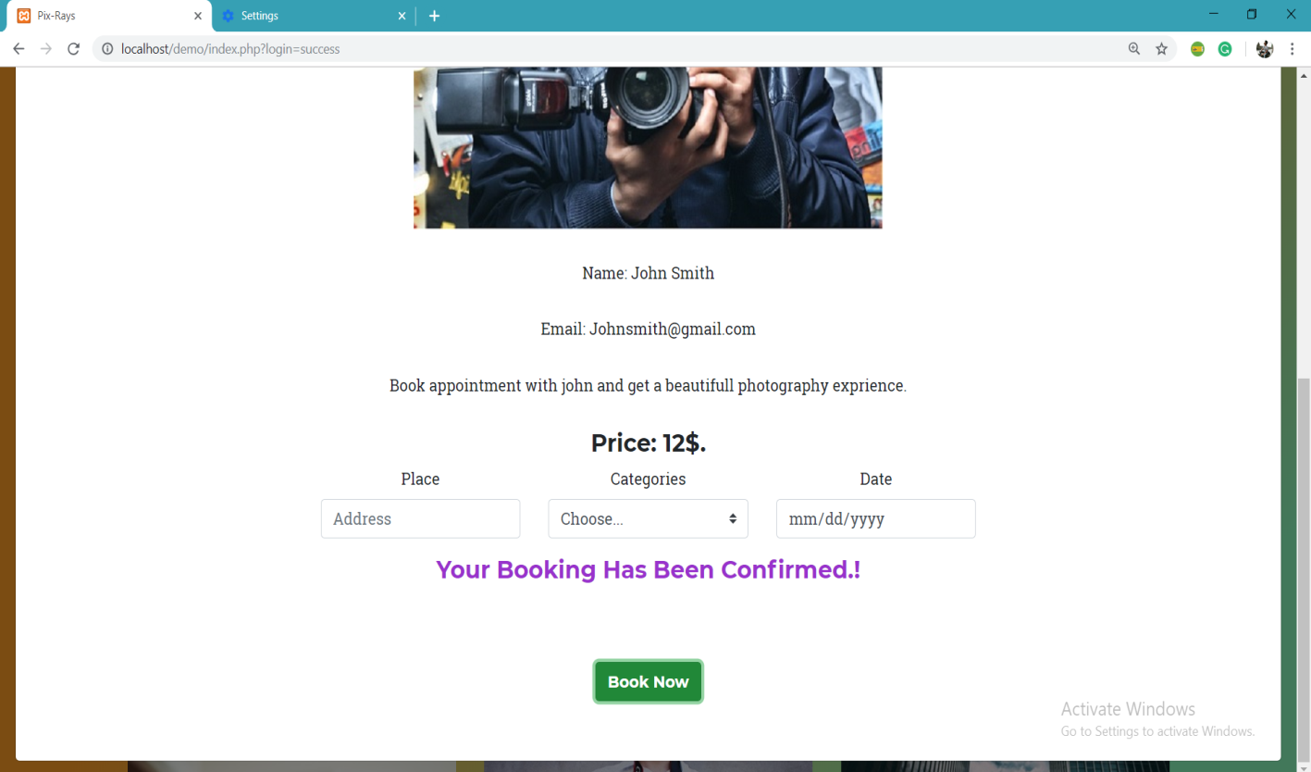

Booking Details:-

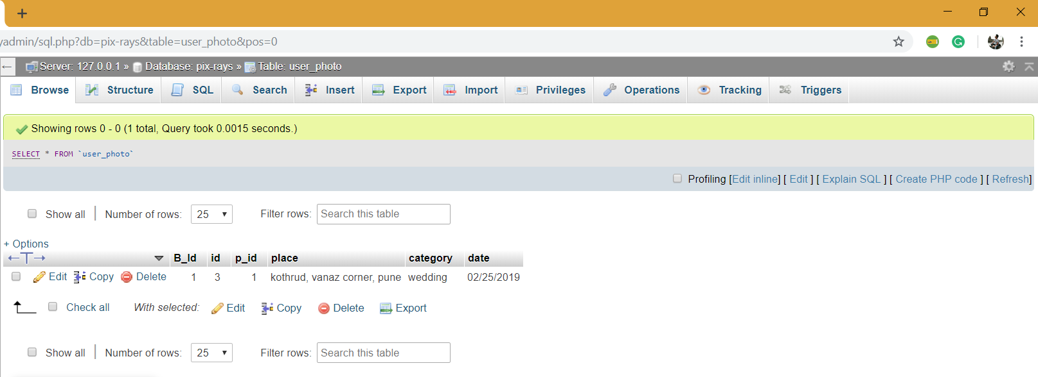

All table details

Registered user’s Table:-

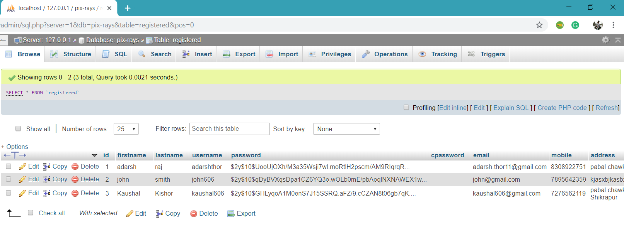

Photographer’s Table:-

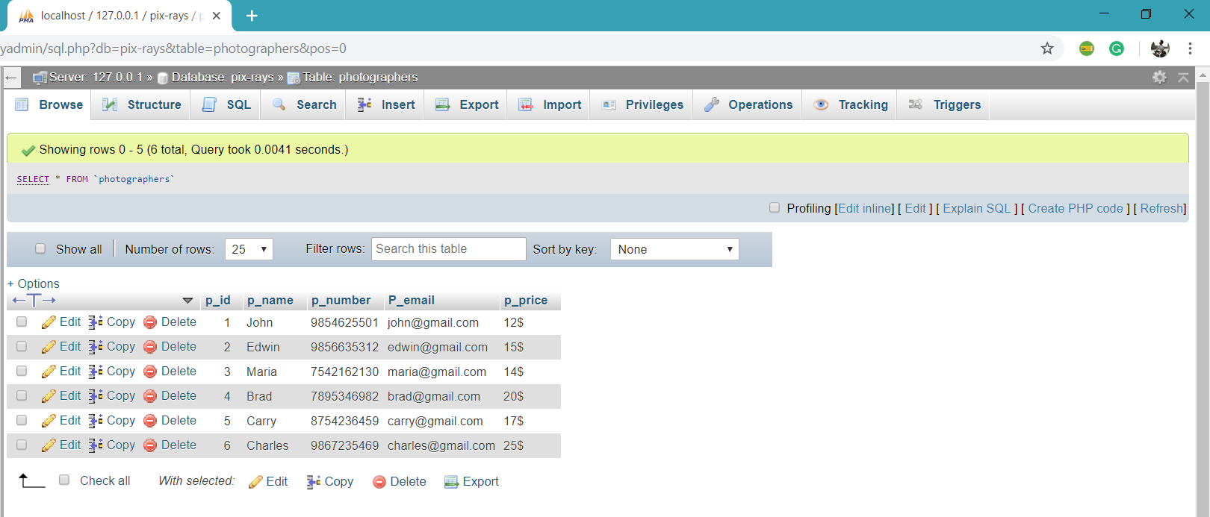

Booking Table:-



**Testing**

At the beginning of the implementation phase of the system, it is observed that the user is unaware of the miracles of the computerized system. But soon comes In contact with this type of fabulous working with computer and prefers work only computer

The major Objective that has been decided in the initial phase of the requirement analysis is achieved successfully. After implementation the System provides reliable results.

The system is totally menu driven & user friendly, which makes it easy for the users even with limited knowledge of computer environment to operate the developed system.

The system avoids the drawbacks of the existing manual system & the validation facility of the system totally eliminates the chances of wrong data entry, which essential for generating error free execution.

It has following commendable features:

User friendly

Time saving

Reduces Effort

At least, I would like to tell that this project is a good learning experience for me. Though this project is not so Complex, it has given me the confidence to use computerization over wide range of application. Personally it has prepared me for the entry into the computerized world. And with the experience of this project, I am sure that I am ready to enter into professional world of computerization.

**Advantages**

Due to the ONLINE PHOTOGRAPHER BOOKING PORTAL will enjoy following advantages:-

* On the basis of this system, it is easy to recognize the active processing of the system.
* We can easily manage the contents of the system.
* Using this system, retrieval of information is done very easily.
* It is suitable for storing the details of users which is very User friendly.
* It is easy to provide services to people who are very busy in their work or not able to do it manually.
* Time Saving.
* Prompt services.
* Reduction of Human Effort.
* Ultra modern technical environment.
* Help in future plans.
* Useful in development & growth.

.

**Drawbacks and Limitations:**

* The only flaw it has is that the user can book a photographer for one day only. If the user wants the booking for more than one day continuously it’s not possible, the user will have to make booking again for the other day if want.

**Future Enhancement**

* **As** per user requirement we can include more details to system that can be :
* More services will be added related to photography.
* EMI payment.
* Book a photographer for more than one day at a single booking.
* Different mode of payments.

Conclusion:

* The quality of the portal depends on the results of the phases in the system development. The portal quality includes the modularity, good documentation, user friendliness, maintainability etc.
* The portals’s reliability depends on the less chances of failure and enhancements in the system even in stress situations far as above developed system is concerned, I have tried to make the system as user-friendly as possible where the user can handle the system very comfortably.

During detail designing, the system is designed in to the module so it is easy to understand the system during maintenance. More over every screen is itself self-explanatory, which makes it altogether easier to work with the system

**Bibliography**

Books:

1). Internet Programming (PHP) by Rajinder Arora & Kalpna Joshi.

Internet:

1). W3schools.com references.

2). Edwin diaz course in PHP on Udemy.